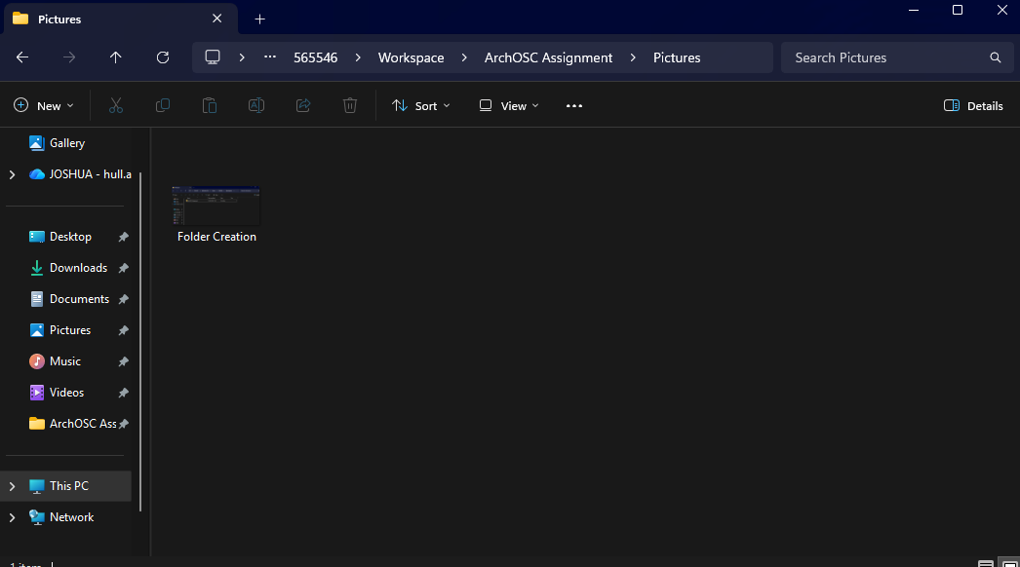
Lab 2: GitHub and CICD Lab 1

Figure 1
Figure 1 shows the requested screenshot within the newly created folder. This was done by following the provided file path, right clicking, creating a new folder called “ArchOSC Assignment”, then creating a new folder called “Pictures”, and adding a screenshot of the folder to this.
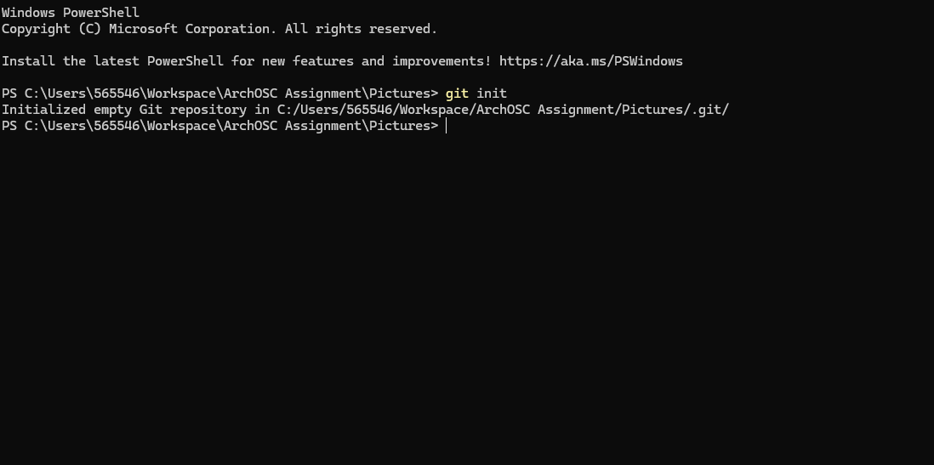

Figure 2
Figure 2 shows the “git init” command being ran from the newly created “Pictures” folder within “ArchOSC Assignment” folder. This was done by right-clicking in the folder and selecting the “Open in terminal” option.
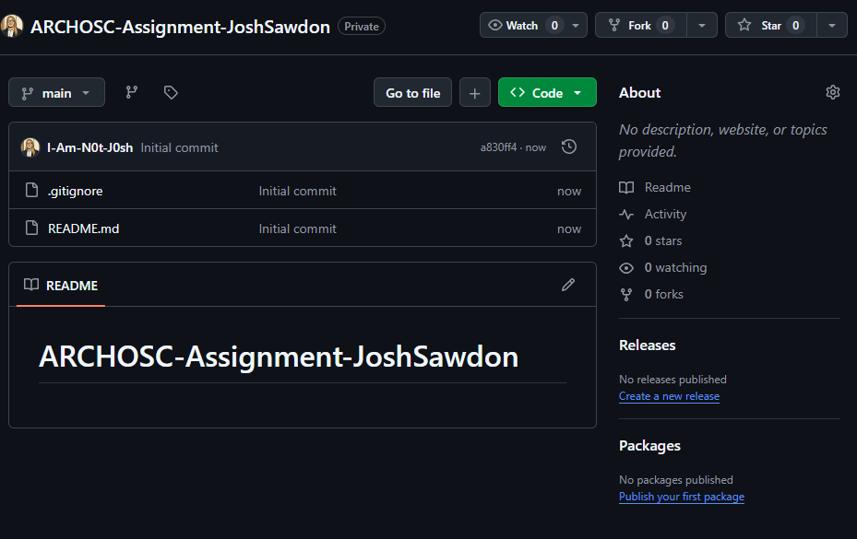

Figure 3
Figure 3 shows the GitHub repo has been created with the requested name of “ARCHOSC-Assignment-JoshSawdon”. This was done via the home screen on Github -> Repositories -> New. The requested details and settings where then implemented.
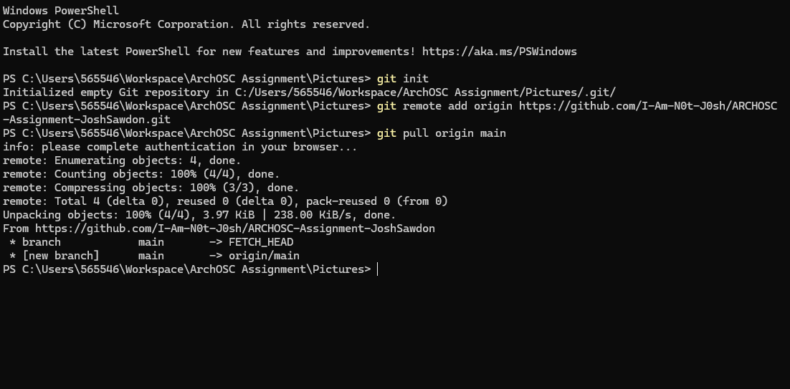
Figure 4
Figure 4 shows the commands listed to set the source for the repo (see lines 8 and 9 in Figure 4), then the command to pull the repo down to the file path (see line 10 in Figure 4). As shown via lines 11 – 19 in Figure 4, this was successful and replicated the screenshot shown in the task page.

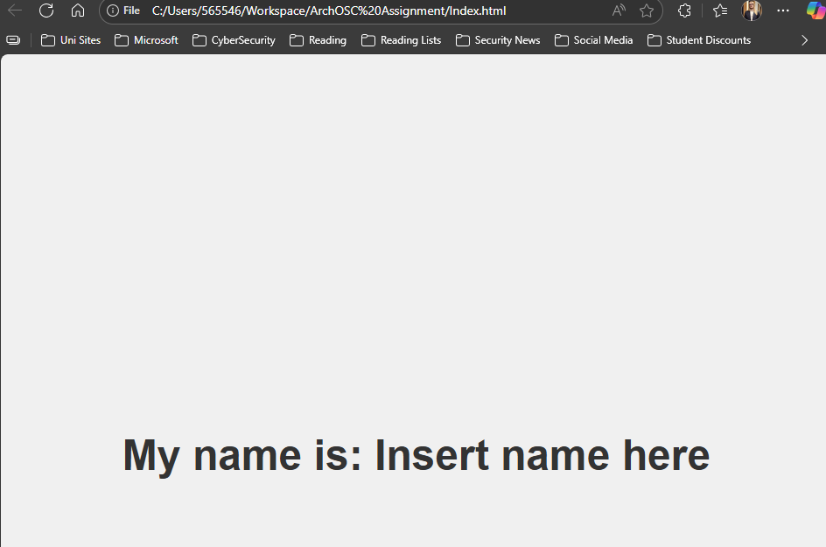

Figure 5
Figure 5 shows the created webpage as requested, including the URL which shows the path in which “Index.html” is saved. The code used for this was the exact code from the assignment brief in order replicate the image that was provided within the brief.
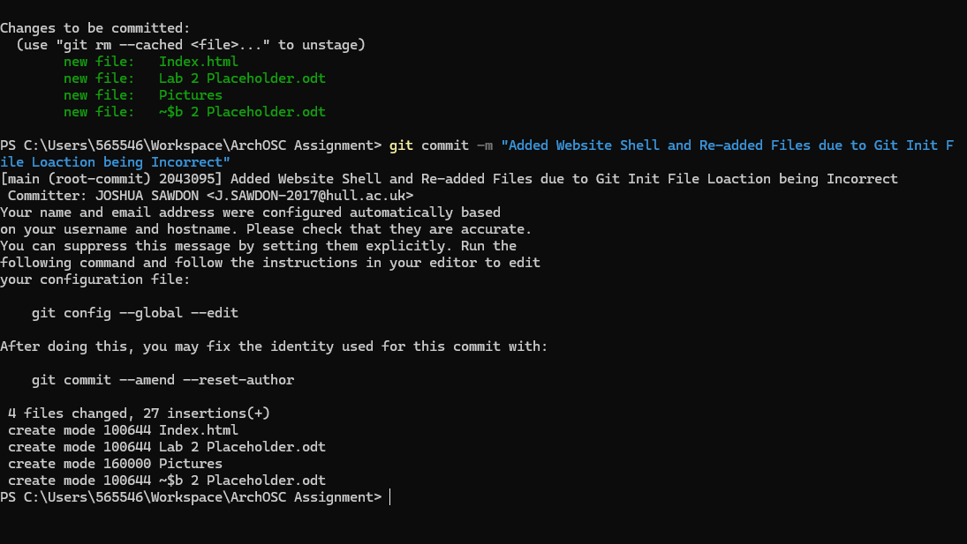
Figure 6
Figure 6 shows “git status”, “git add .” and “git commit -m “Added Website Shell and Re-added Files due to Git Init File Location being Incorrect”. This has slightly deviated from the instructions due to an error being spotted. The “git init” command was ran from a subfolder within the “ArchOSC Assignment” folder rather than the “ArchOSC Assignment” folder itself. To amend this, I removed the link from the subfolder then re-ran the command to link the correct folder to the GitHub repo.
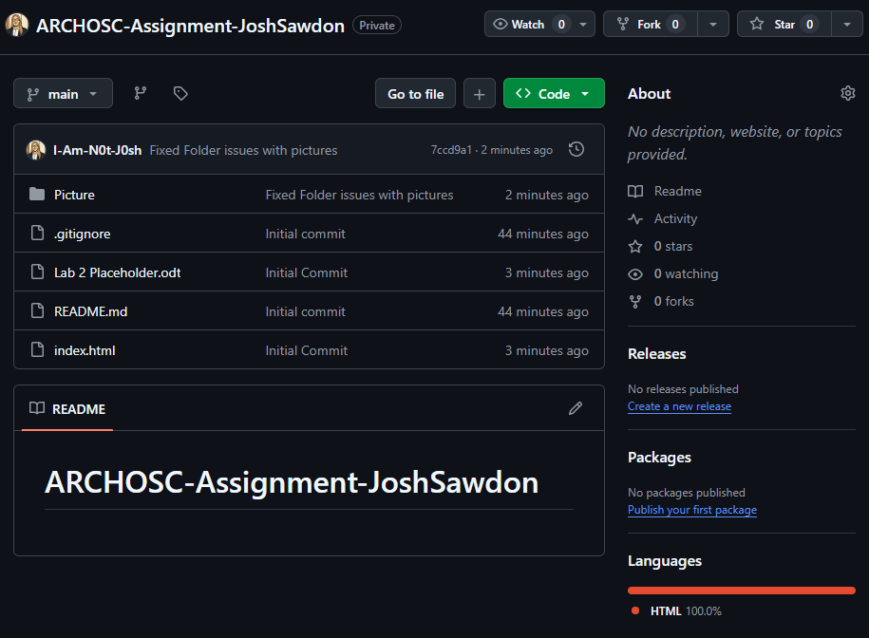
Figure 7
Figure 7 shows the updated GitHub repository following the “git push – u origin main” command. This has taken the changes I made to the folder the repo is copied locally to, and pushed them to the branch in the GitHub hosted repo called “main”.
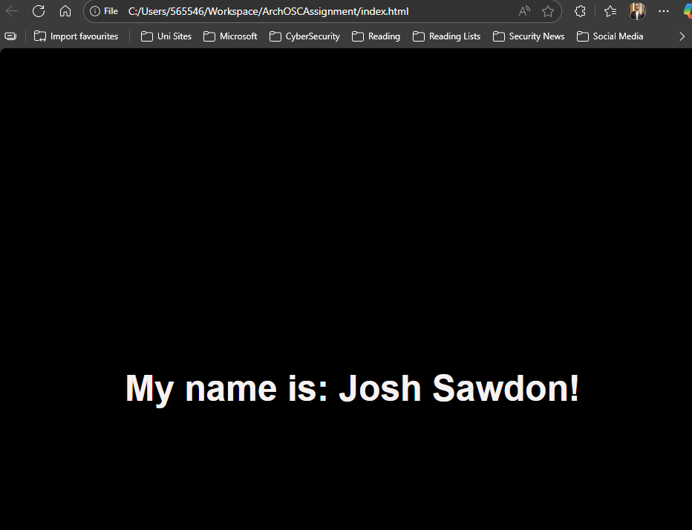
Figure 8
Figure 8 shows the updated index.html file opened as a website. 3 changes were made to this:
1. The text was changed to show “Josh Sawdon!”.
2. The background colour was changed to black.
3. The text colour was changed to white.
These changes were all made in the .html file and completed within Visual Studio Code by manually entering the new values for the heading and both colours.
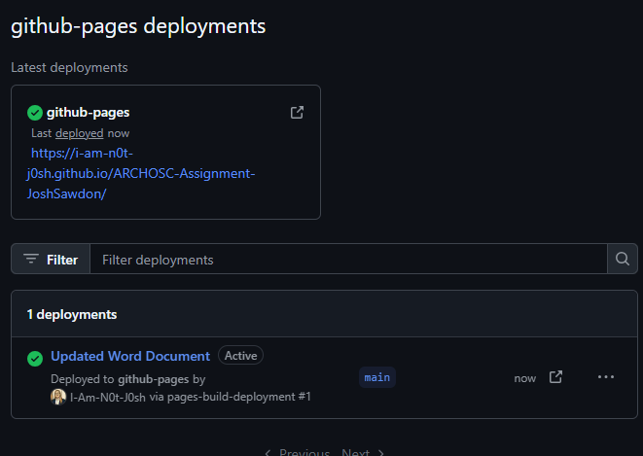
Figure 9
As a pre-requisite, I had to set the repo to public as I do not have an enterprise account at present. Figure 9 shows the GitHub Pages deployment for the “ARCHOSC-Assignment-JoshSawdon” repo. This was done by going into “Pages” under “Code and automation”, then selecting the “main” branch, and deploying. This then took a few minutes to show on the main page but eventually showed as a deployment.

